PWA Video 28 deleting recipes

<https://www.youtube.com/watch?v=zdb8_a0DXTg>

could do in a couple of ways like adding an event listener to the trash icon – not doing this way because

we would need to attach an event listener to each trash icon , not great for performance

would also need to add an event listener to each new recipes trash icon

So will use event delegation. Add the event listener to the surrounding div

That div is the one with class of .recipes so if there is a click anywhere inside that div it will fire a callback function. In that function will check to make sure that the trash icon was what was clicked on.

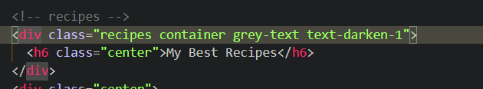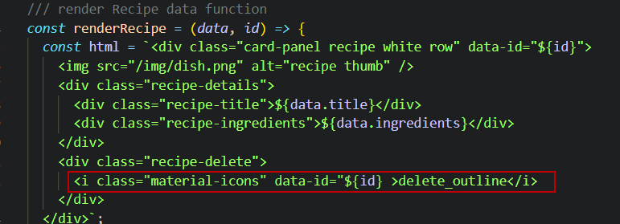

? have we clicked an i tag ?

Ui.js

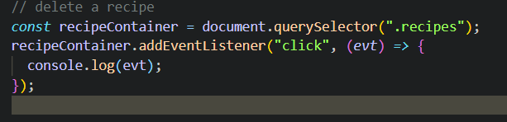

Target tag name of image

